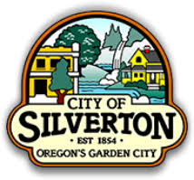
City of Silverton
Final Written PR Plan

University of Oregon
JCOM 472: Public Relations Campaigns

Denali Herrick, Joel Salgado, Mery Gurung,
Bianca Abello, McKenzie Martin

Table of Contents:

- Memorandum … 3

- Final Plan … 4
  - Situational Analysis … 4, 5
  - Target Publics … 5
  - Operational Context … 6, 7, 8
  - Goals and Objectives … 8
  - Strategies … 9
  - Tactics … 9, 10, 11
  - Key Messaging … 11
  - Budget … 11
  - Timeline … 11, 12
  - Evaluation Plan/KPIs … 12, 13

- Sustainability Communication Plan … 13, 14

- Deliverables … 15, 16, 17

- Slide Deck … 18 - 36

MEMORANDUM

To: Macy Mullholland
From: City of Silverton SOJC PR Team
Date: December 13, 2024
Subject: Final Project Memo

Summary of Work:
This is a class project for JCOM472 Public Relations Campaigns class, and we are creating an updated communications plan for the City of Silverton. The campaign seeks to boost resident participation and increase the frequency and accessibility of news that will stay true to the City of Silverton’s small-town values. This includes details such as being community-first, simplicity, and love of nature.

The City of Silverton’s current communication plan is outdated and has difficulty reaching its target audience.

We are striving to make a communication plan that is specific to the City of Silverton’s current needs and adheres to its resident's preferences. Our knowledge of Silverton has come from learning, researching and visiting the city. Through this process, we gained a deeper connection to the city that has allowed us to create many deliverables that showcase the heart of Silverton.

Next Steps:
Building on the deliverables provided, we recommend that the City of Silverton:
- Launch a City Manager subscription-based memo that is distributed once a month via email.
- Activate a city-run Facebook group to allow better control of information flow between residents and the city.
- Continuously inform the residents of the communication updates and how to join.

Long-term
Moving forward, we believe it would be beneficial for the City of Silverton to:
- Strengthen its connection with local businesses
- Review the communication plan annually and make adjustments as needed
- Partner and increase involvement with the local schools

Final Plan

Situational Analysis

Background on Current Communication Methods:

The City of Silverton is a tight-knit community that relies on various communication outlets and has a strong preference for traditional communication methods. Residents appreciate Silverton's small-town charm and favor in-person interactions and word-of-mouth communication. Information is easy to access for residents who are seeking out information. However, the city is struggling to target the individuals who are not proactive. The City of Silverton communicates to its residents through quarterly newsletters, monthly subscription-based emails, town meetings, social media, and its website. These outlets effectively reach proactive residents but fall short in engaging those who are less inclined to actively seek information.
A primary challenge for the city is that many residents rely on a third-party Facebook group, Silverton Connections, to receive the majority of their town-related news. While the group is highly influential and serves as a primary communication hub for most residents, it operates independently of the city. The City of Silverton does not have the ability to control and verify the information shared in the Facebook group. However, the city maintains a positive relationship with the group’s administrators, offering potential opportunities for collaboration.
Feedback from residents highlights a perceived lack of community engagement events. This gap presents a unique opportunity for the city to strengthen its relationship with residents.

SWOT Analysis:

Strengths  - Strong town pride and residential loyalty  - Strong town reputation  - Tourist Destinations - Silver Falls, The Oregon Garden, The Gordon House | Weaknesses  - Lack of communication between residents and the city  - Residents have trouble with digital media  - Lack of community events and engagement  - Residents resist change  - New residents think the community can be cliquey
Opportunities  - Grow tourism  - Draw attention to local business  - Grow communication between the city and its residents | Threats  - Competing small towns in Oregon  - Advances in technology  - Local economy

Target Publics

City of Silverton Residents

The residents within the city limits of Silverton, Oregon, are the primary audience of the communication plan. Ensuring strong, consistent communication between the city and its residents builds trust and ownership. A strong communication with the target audience assists the communication with secondary audiences and stakeholders.

Residents in Surrounding Towns

Residents in the towns surrounding Silverton, Oregon, will also rely on the communication plan. Therefore, they are a secondary audience. While not directly in the city, surrounding towns rely on the City of Silverton’s resources. Their residents support Silverton’s business and economy and hold the potential to attend city events.

Visitors & Tourists

The City of Silverton’s economy is heavily dependent on visitors and tourists. Therefore, they are a secondary audience. The communication plan targets them directly. They need to be able to easily access information regarding the city, its amenities and its resources.

Key Stakeholders

Additional groups have been identified as key stakeholders and will be impacted by the communication plan. It is crucial that these groups stay informed and maintain strong communication to increase cooperation. These additional key stakeholders include City of Silverton employees, local businesses, community partners, Silverton Civic and Social Service, and local and statewide media.

Operational Context

City of Silverton Summary

The City of Silverton, located in Marion County, Oregon, was founded in 1854 and officially incorporated in 1885. Before it was founded, the land was occupied by the Kalapuya Native American tribe. The area is rich with fertile soil and natural resources for sustenance. Silverton is a hot spot for farming and development. In addition, the city draws in millions of tourists each year due to its proximity to Silver Falls State Park and the Willamette Valley. The City of Silverton prides itself on its small-town appeal and historic downtown. Its location provides easy access to urban amenities with its proximity to Salem, Oregon.

Silverton Demographic Breakdown

Silverton, Oregon, lies in the Willamette Valley. As of 2024, Silverton, Oregon has a population of approximately 10,679. The town is predominately white, with nearly 78% identifying as white alone. As of 2022, the median age in Silverton is approximately 38 years old. With the charm of small-town life comes a slower adoption of technology. Many residents are new to tech and aren’t the most tech-savvy. This has created a unique community where traditional ways still thrive. You’ll find residents who face difficulties using QR code surveys and prefer face-to-face interactions over emails.
.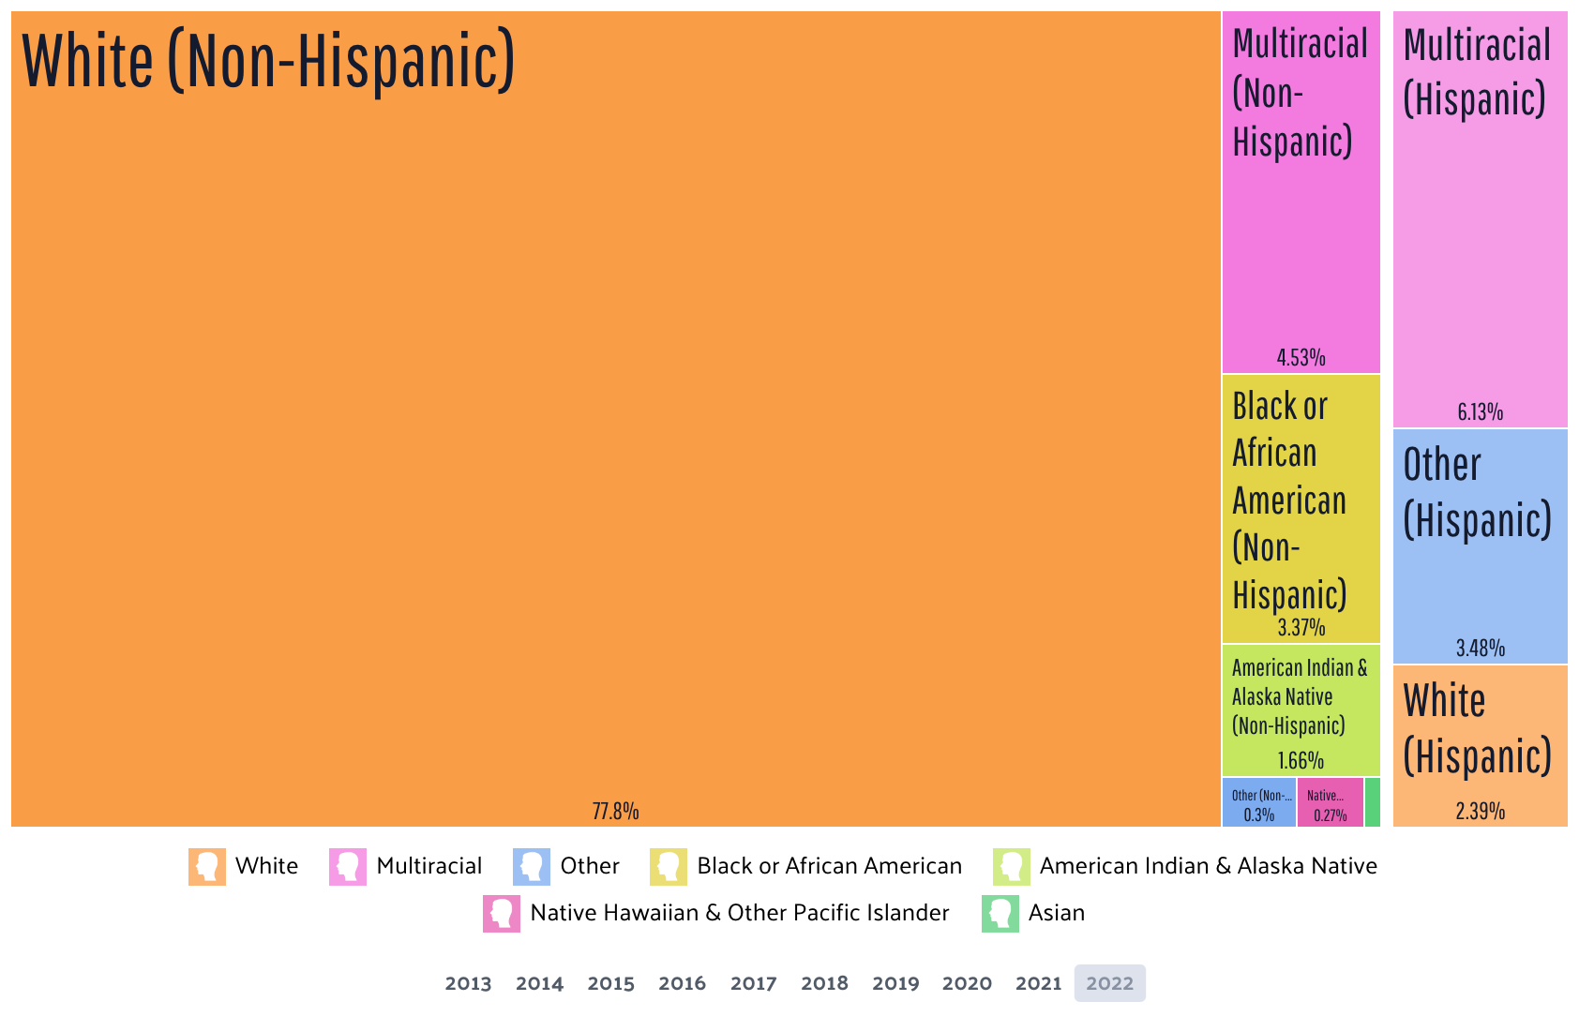
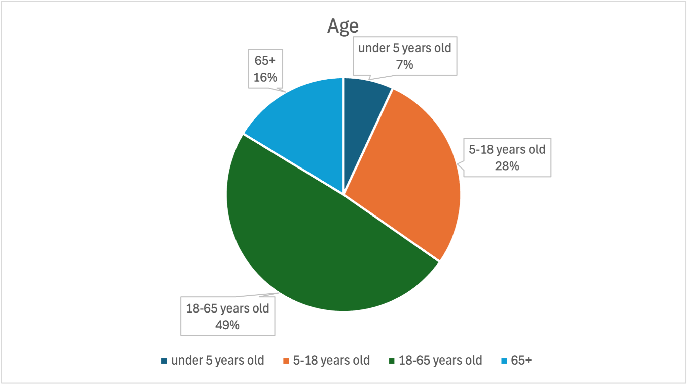

In 2024 Silverton, Oregon, saw a positive trend in its economic landscape. The median household income is around $79,375, while the per capita income is approximately $39,933. These numbers reflect the town's stable economic growth and provide a snapshot of the financial well-being of its residents. Additionally, the average household income has reached about $105,129, indicating a diverse range of income levels within the community. The median home value has climbed to roughly $498,000.

Silverton Tourist Reports

The City of Silverton is a popular destination for tourists with many attractions, including The Oregon Garden, The Gordon House, and Silver Falls State Park. With its welcoming small-town atmosphere, Silverton is admired for its natural beauty and outdoor activities. Silverton hosts several festivals every year, including the Homer Davenport Community Festival, Silverton Hills Strawberry Festival, and Silverton Christmas Market.

After viewing reviews and forums on TripAdvisor and Reddit, the attractions in Silverton are enjoyable for visitors overall. The Oregon Garden is a beautiful area to visit but could have better maintenance. The Gordon House is praised for being the only Frank Lloyd Wright designed structure in Oregon and includes an informative tour. As the state’s only rainforest, Silver Falls State Park and Oregon’s “Crown Jewel”, have hiking trails for hikers of all levels through diverse forest landscapes and are described as a scenic experience by visitors.

On Reddit and Niche, locals in Silverton write that the community has cliques due to the small-town feel. There are not many gatherings for those who don’t have friends in the area. Some locals prefer to spend their free time outside of the town and make the drive over to Salem or Portland. Silverton is described as a quiet and beautiful place to live in, but the residents tend to have mixed emotions regarding politics.

Competitor Small Town Communications Audit

The City of Silverton’s competitors include small towns in Oregon and neighboring cities. Cannon Beach, Oregon, has a population of 1,519 and relies on a tourist-driven economy – similar to Silverton. Cannon Beach has an easy-to-use, up-to-date website that allows locals and tourists to get the proper information. The city prioritizes online communication for events, emergencies, and news & announcements through its website. The city website offers a community bulletin, the city manager’s monthly report, public notices, sign-up links, business resources, etc. -- the go-to for all things Cannon Beach, Oregon. Cannon Beach offers a strong, versatile communication format that can be used to model the City of Silverton’s new communication plan.

Additional research was conducted on small towns across the United States. The towns include Glastonbury, Connecticut, Galena, Illinois, and Winslow, Arizona. Each city has qualities similar to those of Silverton, Oregon, and has exceptional communication styles that can be learned from. Galena, Illinois, has successfully marketed its same small-town appeal while staying true to its historical elements. Their online presence communicates both. Winslow, Arizona, has a population of 8,741. The primary communication channels for locals are their website, social media, and the city app. The unique city app provides notifications, real-time alerts, events, and documents.

Goals and Objectives

We developed communication goals that fit two of the small-town values of the City of Silverton - simplicity and a community-first lifestyle. The first goal is to have consistent information flow from the City of Silverton to residents to improve transparency and trust. The first objective for this goal is to ensure a 100% increase in email subscriptions and a 25% increase in website traffic on key information pages (e.g., city projects and event announcements) within a year. The second objective is to have a city-run Facebook group that consistently shares city information and emergency alerts which grows to 2,000 resident members within three months of launching.

The second goal is to enhance community engagement. The first objective for this goal is to increase community engagement by 20% over the next year by implementing a city chatbot and feedback system. Success will be measured by participation in city-led surveys, event attendance, and consistent two-way conversations between the city and its residents. The second objective is to increase community engagement by 20% over the next year through city events at the Gordon House that encourage residents to learn more about their city and other residents.

Strategies

We will use an integrated communication approach to boost resident participation and increase the frequency and accessibility of news that will stay true to the City of Silverton’s small-town values. By embracing Silverton’s close-knit atmosphere, our plan will maintain a tone and style that resonates with residents.

Silverton residents and City staff value the local environment and community-first approach, which will be reflected in the communication plan. Provide ways for Silverton residents to have a two-way conversation with city staff to increase trust and transparency.

Simplicity in communication is a priority for both the City staff and residents. This will be reflected through “less is more” communication and easy-to-understand messages. We will prioritize ensuring residents receive news more easily, frequently, realistically, and including easy-to-understand messaging.

Tactics

Tactic #1:

Email Subscription:
- City residents prefer email for digital communication. We will help grow the city’s email database through the city’s website to increase subscriptions.
- Redesign the email subscription tab on the city website for signing up for consistent city alerts through an email subscription.
- This will help achieve consistent communication from the city to the residents while also making the website more user-friendly.

Tactic #2:

News Frequency: Getting constant information flowing from the city to the residents is important.
- Launch the City Manager Monthly Memo by the end of Q2
- Ensuring the monthly memo is posted on the website and linked via email blast to all subscribers
- Provide a channel for residents to share their feedback and link this to an email
- Include features on local businesses and residents to spark community engagement and support businesses

Tactic #3

Facebook Group: A city-run Facebook group will help share reliable news while honoring residents' preferences to receive updates via Facebook.
- Launch the Facebook group that will only be accessible to the City of Silverton residents and its surrounding town residents
- Encourage residents to sign up through informational postcards and/or fridge magnets sent to homes
- Make incentives to join the Facebook group that simultaneously promotes local business and stirs excitement
- Uphold posts to a consistent, transparent, and relevant standard

Tactic #4

Feedback System: To grow community engagement and to understand what the residents want, the city needs to implement a feedback system through a website chatbot and email replies.
- Create a chatbot on the website that uses AI for automatic responses during non-working hours and allows for real-person responses during business hours
- At the end of all external emails, include a note encouraging residents to reach out if they have any questions or concerns by replying to the email or through the website’s chatbot

Tactic #5

Community Events: Hosting events throughout the year at the Gordon House will increase resident engagement with the city and each other.

- Connect with the Gordon House and other local sites to host events
- Send emails and postcards inviting residents to the events
- Share the events with schools to encourage students and families to participate
Community Event Ideas:
- Town Potluck:
  - Host at the Gordon House
  - Residents bring food to share
  - Have different themes like BBQ, harvest, family favorites, etc.
  - Activities: games for kids, local musicians, raffle with money raised going to a local foundation or organization
- Winter Festival:
  - Christmas lights on N. Water St.
  - Activities: food trucks, winter kids activities, local high school marching band play, local businesses table
- Art and History of Silverton:
  - Host at the Gordon House
  - Collaborate with the Silverton Murals Society, Silverton Country Historical, the Oregon Garden, local artists and musicians, etc.
  - Have educational and fun activities for families such as a scavenger hunt

Key Messaging
Our key messaging emphasizes Silverton’s identity as "Oregon’s Garden City," reflecting its small-town charm and values. Drawing from our focus on simplicity, community, and a love of nature, we aim to build strong connections with residents and visitors.
Copy: Welcome to Silverton, Oregon, a place where small-town values and natural beauty create a unique experience. Known as “Oregon’s Garden City”, Silverton offers a perfect blend of simplicity, community, and a deep love of nature. Come experience the heart of Silverton through its local businesses, friendly neighborhoods, and vibrant downtown. Discover Silverton - a destination where everyone feels at home.

Budget

Communication Materials
- Fridge Magnets $774.90 (Qty 5000 Magnets)
- Postcards $297 (Qty 600 Postcards)
- Website Chatbot Starts at $30/month per seat
Events
- Gordon House $1000
TOTAL ANNUAL COST: $ 2,431.90

Timeline

The timeline outlines a clear roadmap for the City of Silverton, detailing achievable goals within a year. Recognizing ongoing projects, we recommend prioritizing those that can be launched earlier in the year to ensure steady progress and effectiveness. At the end of the year, the City of Silverton will have a clearer understanding of the effectiveness of its Communications Plan.

Phase 1: Spread the Word (January-March)

Winter 2025:
- Develop a city-run Facebook group
- Distribute email subscription information

Phase 2: Make Connections (April-June)

Spring 2025:
- Launch City Manager memo
- Launch Facebook group

Phase 3: Transparency (July-December)

Summer 2025:
- Organize a partnership with schools or local organizations (ex. Gordon House)
- Business and resident features

Fall 2025:
- Review Communications Plan progress
- Upload annual reports to the website

Evaluation Plan & KPIs
An Evaluation Plan and Key Performance Indicators (KPIs) are critical components of any project or communication strategy to measure success. We have identified specific KPIs to measure the plan's success across transparency, engagement, and sustainability efforts. We will assess the success of this communication plan through a combination of quantitative and qualitative methods. These evaluations will measure the effectiveness of the tactics employed, resident engagement levels, and alignment with the City of Silverton’s values

Evaluation Plan
Goals
- Improve transparency and trust between the City of Silverton and its residents.
- Enhance community engagement.

Transparency and Trust Measurements
- Email Subscriptions
- Website Traffic
- Facebook Group Membership

Community Engagement Measurements

- Event Participation
- Feedback Collection
- Survey Responses

Sustainability Communication Plan
Nature is an integral part of Silverton, especially since it is so close to the beloved Silver Falls State Park. For the second part of the plan, we created a sustainability communication plan that is based on the city’s love of local nature and wanting to preserve and appreciate it for years to come.

Goals and Objectives
The goal is to develop a reputation for the City of Silverton as a sustainable city and cultivate local pride in the nature that surrounds the area. We have three objectives for this goal. The first is to have two public events per year related to nature and sustainability. The second is to have a 20% increase in participation in events and sustainability efforts in a year. The last one is to have a 50% increase in knowledge of how Silverton takes care of the local nature in a year.

Strategy
There are six parts to the strategy. The first is to focus on local nature. The Silver Fall State Park is very important to the City of Silverton. So, we want to connect sustainability communication efforts to local spots in Silverton such as the park, The Oregon Garden, and The Gordon House. The second is communication will be centered around the values of Silverton such as community-first, nature sustainability, and simple living. The third is to focus on collaboration. The city should collaborate with Sustainable Silverton and local universities to educate and engage the community in sustainability action. Also, they should promote their desire for volunteers who have an interest in helping with sustainability in Silverton. The fourth is feedback. The city should provide clear ways to receive feedback from residents about their opinions or ideas of sustainability, allowing for more transparent and trustworthy two-way communication. Lastly, the city should be transparent with its residents by providing frequent updates and news about its sustainability efforts. Also, they should answer questions in a timely manner to increase trust.

Key Messages
The two key messages that we want residents to receive are that Silverton values community-driven sustainability and they want to protect and celebrate the local nature. Sustainability action comes from the wants and needs of the community and is driven through community effort. Also, Silverton should showcase projects that protect and work with the local environment and encourage residents to live sustainably.

Tactics
There are four parts to the tactical plan. The first is using community events. One idea for this is to collaborate with The Oregon Garden to host Earth Week activities each April. Some activities that the city could do for this are planting a tree, having a family event with crafts, food, and sustainability learning opportunities, having a scavenger hunt through the city, having clothing and toy donations, or having a bike to work or school day. A second idea for a community event is to host a half marathon run or bike race between the Gordon House and Silver Fall State Park during the summer.

The second tactic is to host a friendly competition between residents. The city could collaborate with the Silverton Murals Society to host a competition for residents to submit mural ideas and designs related to nature and sustainability for Silverton’s next mural. Another idea is to have residents send nature pictures to the city, which can be featured in various ways such as on social media.

The third tactic is to utilize communication materials. The city could send one email every quarter providing information about sustainability efforts and providing tips on how residents can help keep Silverton clean and healthy. Also, a section of Our Town newsletter can be dedicated to nature and sustainability events.

The last tactic is to collect feedback. Once every five years, send out a survey, asking residents about what sustainability efforts are important to them. Also, at the end of the sustainability emails, encourage residents to give feedback and ask questions about Silverton’s sustainability efforts.

Deliverables/Mockups
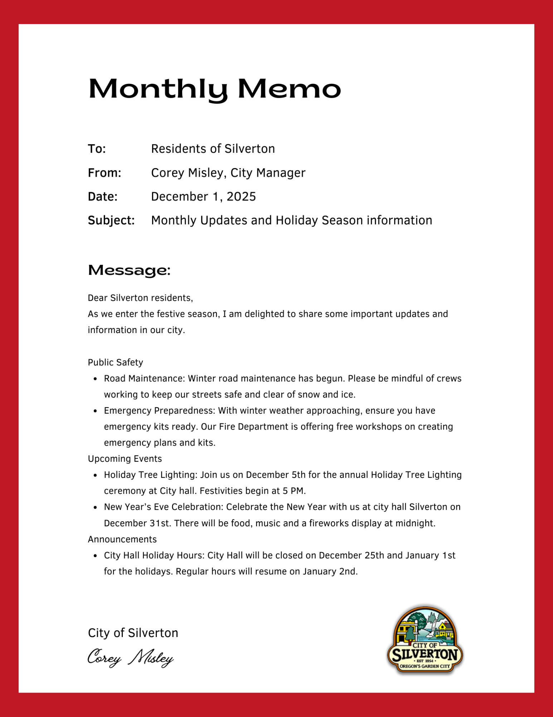
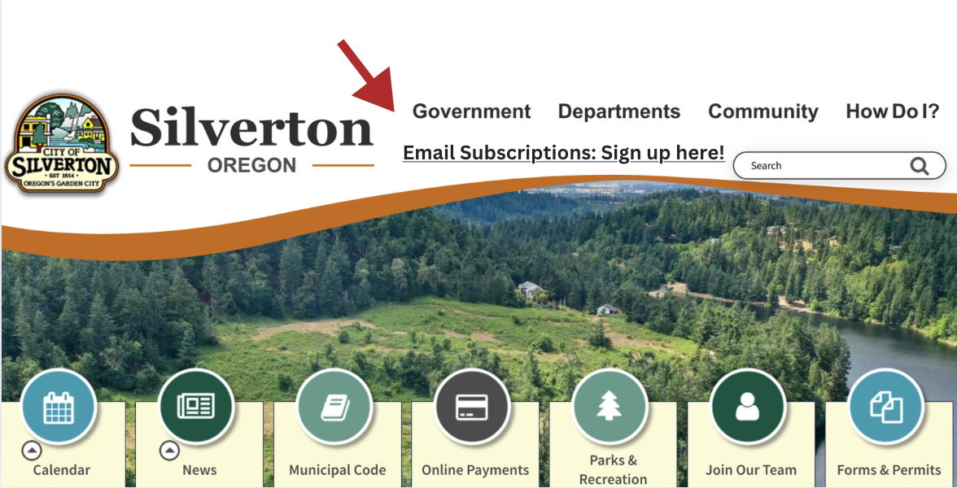
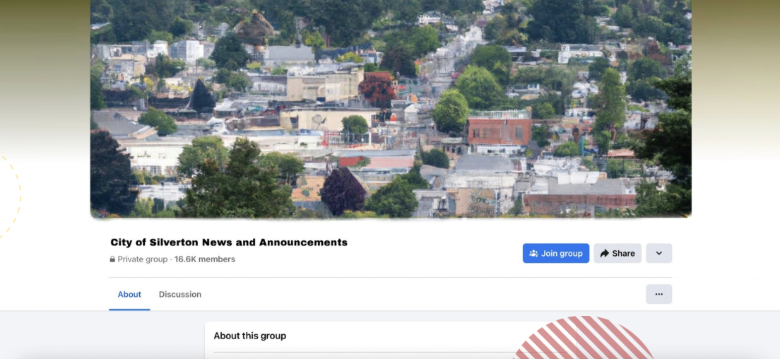
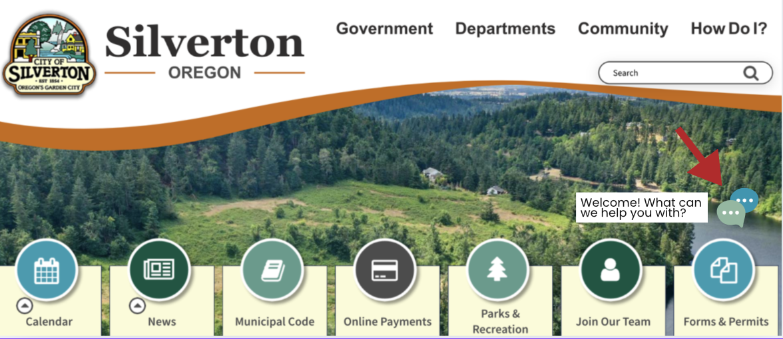
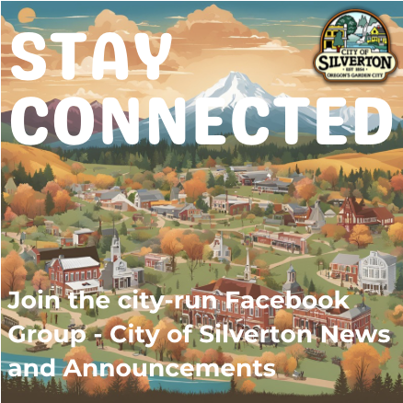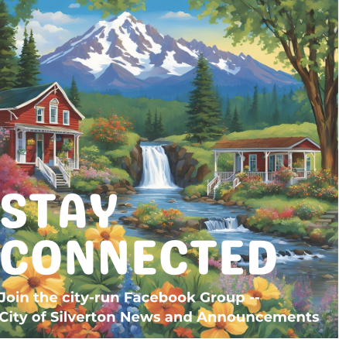
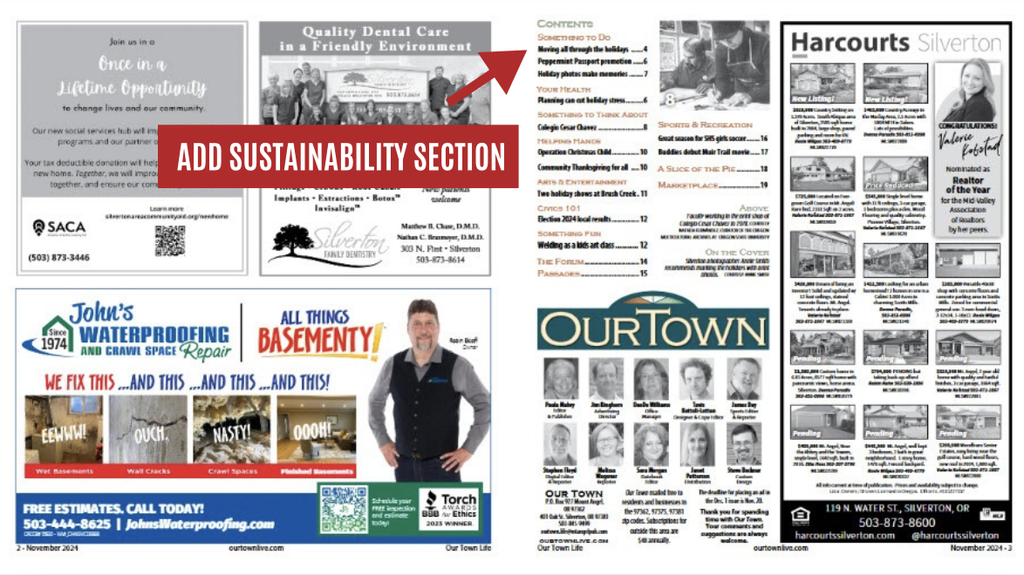

Slide Deck
